**MILESTONE 2**

**Project : Competitive Marketing Dashboard**

**Introduction:**

The Competitive Marketing Analysis Report is a comprehensive tool designed to provide businesses with actionable insights into their sales and marketing performance. In today’s data-driven world, making informed decisions requires the ability to analyze and interpret vast amounts of data effectively. This report leverages Power BI to visualize critical metrics, offering an intuitive and interactive platform for decision-makers.

The dashboard focuses on key performance indicators (KPIs) such as total sales, channel-wise sales, ROI, and customer behavior across different regions and categories. By integrating multiple datasets and applying advanced business intelligence techniques, the report enables stakeholders to identify trends, uncover growth opportunities, and address inefficiencies in marketing strategies.

This analysis is particularly valuable in competitive markets where businesses must adapt quickly to changing consumer preferences, market dynamics, and emerging channels like social media. Through its intuitive design and robust data capabilities, the Competitive Marketing Analysis Report empowers organizations to stay ahead of the competition and maximize their return on investment (ROI).

**DAX Functions:**

### 1. ****Total Sales**** Total Sales = SUM(Sales[Sales Amount]) **Purpose:** Calculates the total revenue generated from all sales.

1. **Channel Sales (Online, Social Media, Stores, Outlet)  
   Online Sales = CALCULATE([Total Sales], Sales[Channel] = "Online")  
   Social Media Sales = CALCULATE([Total Sales], Sales[Channel] = "Social Media")  
   Stores Sales = CALCULATE([Total Sales], Sales[Channel] = "Stores")  
   Outlet Sales = CALCULATE([Total Sales], Sales[Channel] = "Outlet")  
   Purpose:** Filters the total sales by sales channel to provide a breakdown.

**3. **ROI (Return on Investment)**  
ROI = DIVIDE([Total Sales] - [Total Investment], [Total Investment], 0)**

**Purpose:** Determines the return on investment as a percentage for each channel or overall sales.

**4. **Sales Over Time**Sales Over Time = SUM(Sales[Sales Amount])  
Purpose:** Aggregates sales by date, month, or year to analyze trends.

1. ****Total Sales by Product and Channel**Sales by Product and Channel = SUM(Sales[Sales Amount])  
   Purpose:** Combines product and channel filters to show specific contributions.

**6. **Returns Analysis**Total Returns = SUM(Returns[Return Amount])  
Resolved Returns = CALCULATE([Total Returns], Returns[Status] = "Resolved")  
Unresolved Returns = CALCULATE([Total Returns], Returns[Status] = "Unresolved")  
Purpose:** Tracks the return process and categorizes resolved and unresolved cases.

**7. **Row-Level Security (RLS)**Admin Access = TRUE()  
Regional Manager Access = Sales[Region] = USERNAME()  
Purpose:** Implements security by restricting data visibility based on user roles.

**8. **Sales by State and Channel**Sales by State = SUM(Sales[Sales Amount])  
Sales by Channel and State = CALCULATE([Sales by State], Sales[Channel] = "Online")  
Purpose:** Displays channel performance within different states.

**9. **Top 10 Products by Sales**Top 10 Products = TOPN(10, Product[Sales Amount], Product[Sales Amount], DESC)  
Purpose:** Filters and ranks the top-performing products based on sales

**10. **Trend Analysis**Trend = SUMX(SUMMARIZE(Sales, Sales[Month], "Sales", [Total Sales]), [Sales])  
Purpose:** Evaluates sales trends and patterns over time.

**Model View:**

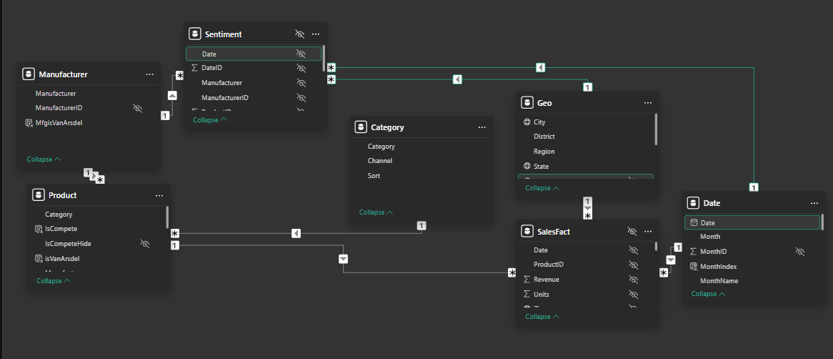

### 1. ****Key Components in the Model****

**Fact Table:**

* + The **fact table** contains transactional data, such as sales figures and ROI, aggregated across different dimensions (channels, products, regions, etc.).
  + Example fields in the fact table:
    1. Total Sales
    2. Online Sales
    3. Social Media Sales
    4. Stores Sales
    5. Outlet Sales
    6. ROI (Return on Investment)

**Dimension Tables:**

* + These provide descriptive attributes related to the fact table for filtering and slicing the data:
    1. **Channel Dimension Table**:
       - Columns: Channel Name, Channel Type (e.g., Online, Social Media, Outlet, Stores)
    2. **Product Dimension Table**:
       - Columns: Product ID, Product Name, Product Category
    3. **Date Dimension Table**:
       - Columns: Date, Month, Quarter, Year
    4. **Region Dimension Table**:
       - Columns: Region Name, State, City

**Hierarchies:**

* + **Date Hierarchy:**
    1. Year → Quarter → Month → Day.
  + **Region Hierarchy:**
    1. Region → State → City.
  + **Channel Hierarchy:**
    1. Channel Type → Channel Name.

### ****2. Relationships in the Model****

The relationships define how tables interact. Here’s an overview of potential relationships:

**Date Table ↔ Fact Table:**

* + One-to-Many (1) relationship based on the Date field.
  + Allows time-based filtering and aggregation.

**Channel Table ↔ Fact Table:**

* + One-to-Many (1) relationship based on the Channel Name field.
  + Enables channel-level analysis.

**Region Table ↔ Fact Table:**

* + One-to-Many (1) relationship based on Region Name.
  + Supports geographical breakdowns and comparisons.

**Product Table ↔ Fact Table:**

* + One-to-Many (1) relationship based on Product ID.
  + Enables analysis of product-level sales performance.

**Page 1: Executive Overview:**

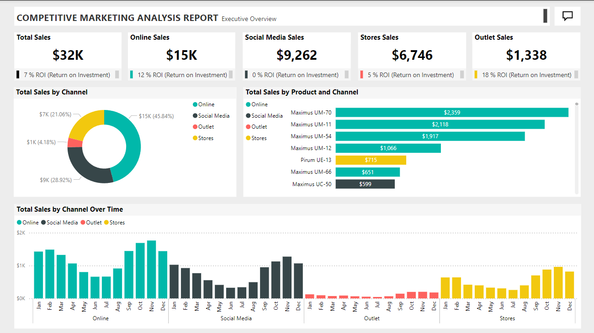

**Page 2: Sales By Region:**

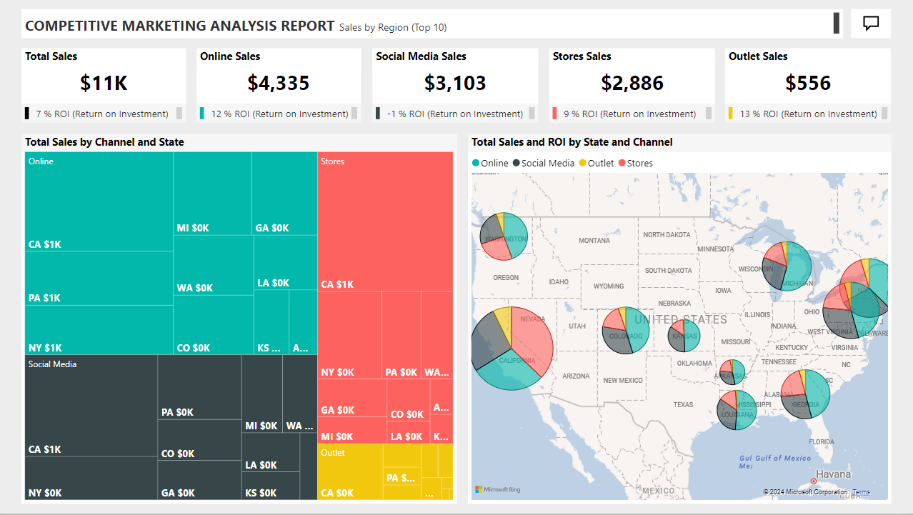

**Page 3:Return on Investment:**

